1. **ROJECT DETAILS**

|  |  |
| --- | --- |
| Project ID | 10140 |
| Project Name | Strengthening Ear and Hearing Care Services in Ethiopia |
| Project Location | Addis Ababa, Ethiopia, East Africa |
| Project Duration | Three years (2022-2024) |
| Total approved budget amount (in EUR) | Euro 1084248.40 |
| Total budget expenditure amount (in EUR) | <200,102.19 > |
| Contract Partner | <St. Paul Hospital Millenium Medical College > |
| Other Implementing Partners | No |
| Responsible person at Partner / Project | Alene Meshesha, MD, Assistant. Prof. ORL-HNS, SPHMMC,  EHC Project Coordinator & Ethiopian Hearing Health Advocate & Netsanet Tekalign-Administration/program Assistant |
| Date of report submission | Jan 17, 2024 |
| Responsible person at CBM | <Samuel Bekele, Programme Officer > |

1. **NARRATIVE REPORT**

## **To what extent were the Objectives achieved?**

**Overall Objective;**

To contribute to improve health conditions of people in Ethiopia by promoting access to cost effective and quality ear and hearing health care services in Ethiopia.

**Specific objective;**

To address the needs of persons with ear and hearing impairment and disability, by supporting the development of sound and efficient services nationally, as well as supporting the development of the National Action Plan for ENT.

A new project agreement was signed between CBM and St Paul’s Hospital Millennium Medical College (SPHMMC) to continue the implementation of the project for additional 3 years (2022 - 2024). Now, the project has finalized the 2nd year of implementation. This year major activity was National population-based hearing impairment survey, which was brought forward to this year due to long delay in the international procurement process of list of various supplies which were necessary for conducting the survey. The survey was finalized, then a validation workshop and manuscript writing were done. Other activities done based on its stated objective were addressing the needs of persons with ear and hearing impairments, the project has performed micro ear surgeries and Audiology screening programs at the Hospital level. Awareness raising campaigns were also held during the survey activities.

Other activities done to meet the project objectives were delivering different levels of training to health professionals to improve their knowledge and skills towards quality Ear and Hearing Care (EHC) services. Furthermore, the project produced and distributed IEC/BCC materials to increase the awareness in the community and health professionals about Ear and Hearing care services, advantage of the Population Hearing Survey and other related issues.

In general, the project has met its goal in retarding the National population Hearing survey completion.

In these 12 months, the project's main activity was the National population-based hearing impairment survey. The survey activities took much of the project staff's time, thus most of the other activities planned to be implemented were on hold. Another challenge the project faced was budget cuts from the country office due to lack of donations. This also affected the planned activities and the project has to set a priority.

# **To what extent were the planned Results achieved or not during the reporting period?**

**ER1 High quality EHC service is provided to the target population Nationally**

During the reporting period, the project managed to do campaigns at St Paul’s Hospital Millennium Medical College in the 1st 6 months. In the campaigns, the major services provided were audiology testing, clinical screening, and Surgery campaign. In addition to this, screening and surgery campaigns are implemented at Garabet Tehadiso Mahber (GTM) Hospital, Butajira and at CURE Children’s Hospital, surgeries were conducted for a good deal of people After the screening and diagnosis, assistive hearing aids were provided. However, we could not manage to achieve the targeted plan for this year due to shortage of time, budget and of some hearing aids.

The major activities in the last 12 months were the launching of the National Population based hearing impairment survey and its implementation. The data collectors training is conducted for 3 days at Embilta Hotel, Addis Ababa for healthcare professionals (ENT surgeons, ENT Residents, Audiometry Nurses and HO) who come from different selected regions. Then the actual data collection process is started immediately till the end of June. The selection of enumeration areas was done in consultation with the Central Statistics Agency (CSA). Based on that our enumeration areas were 100 kebeles in total and in each kebele 25 households were included in the survey. All family members are included on the survey in each of the selected households. The data collection is done in all regions except Tigray region which was excluded from the survey due to security reasons. the validation workshop and manuscript writing workshop were also conducted.

**ER2 Capacity building system will be established by providing trainings for EHC Health Personnel.**

In 2023, the project managed to implement capacity building training on Basic Primary Ear and Hearing Care Training for Health extension workers in selected health centers in Addis Ababa. The selected Health Centers were our survey areas for the population-based hearing survey. Out of 30 invited trainees 27 attended the training. The training is aimed to give the basic knowledge on Ear and Hearing Care. Additionally, Orientation was given to the HEWs on the population survey to increase the response rate of the survey participants. This helped the survey team during the data collection time to get better survey attendance. Other capacity building activities are not implemented due to manpower shortage, since ENT department staff and residents are participating in the survey, shortage of budget and project staff time shortage since the survey activities took much of their time.

**ER3 Health education & promotion system on EHC strengthened**

Under this result area for the last 12 months, celebration of The World Hearing Day (WHD) was done on 3rd of March. This year's WHD was celebrated with different invited stakeholders attending. These include participants from partner organizations, associations of people with disabilities, ENT professionals and a few Media ENA, NBC, EBC. During this symposium, promotional IEC/ BCC materials /leaflets were distributed. This year's celebration is done with the theme of “Ear and Hearing Care for all!” Let’s make it a reality. On the other hand, under this activity, Amharic and Oromiffa version of copies of WHO Ear and Hearing Care Guidelines, other IEC materials about Basic Primary Ear and Hearing care, Amharic and English version on the importance of the population survey were distributed during the survey implementation and during training.

**ER5 Efficient and effective program management is achieved.**

Population based survey is a priority, since it has a big budget, and needs close follow-ups. The project director gave his full time in mentoring and supervision of data collectors’ teams by traveling with the team to different parts of the country. Additionally, the survey report and manuscript writing

The program and finance assistants did their jobs in coordination to deliver the payments on time, collect the necessary attendance and agreements. Additionally, by arranging logistics for each survey travels.

There are activities in each result area which were not implemented during the reporting period. This generally affected the overall achievement of the results. All results are not achieved fully as planned, this is because of manpower shortage at the ENT department and project team for outreach services and campaigns; Budget cut from the donor side which obligated us to made a priority of activities to be done.

# **What key Activities were implemented and what Activities were planned but not implemented in the reporting period?**

|  |  |  |
| --- | --- | --- |
| **Key Activity No.** | **Activity Name** | **Status, achievements, no. of beneficiaries** |
| 01.01 | Provision of supplies related to EHC to 50 selected health facilities in Ethiopia including SPHMMC | not done |
| 01.02 | Implementation of 4 screening outreach programs per year. | not done |
| 01.03 | Perform facility based auditory function screening testing for 1300 persons/ year (Neonates/Children/Adults) | In the last 4 quarters, we did an auditory function-screening test at St. Paul’s Hospital this quarter as planned for the 1st 2 quarters only. It is due to manpower and budget shortage. During the 2quarters campaign a total of – 1567(Male 544, boys 227, Women 624 and girls 172) were screened for auditory function tests by organizing a screening campaign. The project achieved the targeted plan per year (which is 1300 persons per year). The main purpose of doing this auditory function screening testing, was to know the exact number of patients who need either hearing aids, surgeries or other related treatments according to the outcome of the screening. The Majority of the screening results were Sensorineural Hearing loss, Conductive Hearing loss and Mixed hearing loss. |
| 01.04 | Clinical Screening of persons with ear conditions /hearing loss or chronic suppurative otitis media 5000 persons/year (Neonates/Children/Adults) | The clinical screening of persons to detect ear disease or hearing loss has been initially planned to be done throughout 2023. The project managed to do screening at St. Paul’s hospital in the 1st quarter, at GTM Hospital in the 2nd quarter and at Cure Hospital in the 1st, 2nd and 4th quarter. Hence, 1,945 patients were screened in the above mentioned three health facilities. At SPHMMC, a total of 1,377 patients (312 males,213 females, 525 boys and 327 girls)) were screened during the 1st quarter, at Cure Hospital 407 patients (173 girls and 234 boys) were screened, furthermore, at GTM hospital 161 patients(18 boys, 38,girls 42 males and 63 females) were screened, consulted and assessed for possible ear surgery and other ENT related problems. The major findings during this screening were acute otitis media, chronic suppurative, otitis media, Sensorineural Hearing loss, Conductive Hearing loss and Mixed hearing loss.  In total, the project managed to screen a total of 1,945 patients for possible ear and hearing conditions, the annual plan is to screen 5,000 patients per year. The project managed to achieve 38.9% of the year plan. The performance was decreased because the campaign program at SPHMMC was not done due to staff shortage, budget shortage and time constraint. |
| 01.05 | Provision of assistive devices (hearing instruments and accessories) to 200 persons annually. | In this year, the project managed to fit 140 hearing aids on 115 patients (35 hearing aids on 24 boys, 30 hearing aids on 21 girls, 37 hearing aids on 35 males and 38 hearing aids on 35 females) who were qualified for device prescription. Our yearly target was to fit hearing aids for 200 persons. The project achievement is 57.5% from the year plan. The achievement was lower than the plan because we still lack the necessary materials for hearing aids.  Like other clients, provision of these devices not only helped to improve hearing conditions of these patients, but also contributed towards improving their communications, their work/educational performance and social interactions towards reducing stigma and boosting confidence. This will eventually improve their overall quality of life through relieving their stress and embarrassment because such people are usually sympathized due to their hearing condition. |
| 01.06 | Perform 300 ear microsurgeries at SPHMMC and GTM-Butajira annually. | Micro ear surgeries were done for patients at St. Paul’s hospital (only in the 1st quarter), GTM Hospital (in the 2nd quarter only) and CURE Children Hospital (in the 1st, 2nd and 4th quarters). In total 298 patients (59 males, 103 women, 72 boys and 64 girls) got the required surgical procedure in the above 3 hospitals. The major ear conditions which led them to micro-ear surgeries were chronic suppurative otitis media and majority of the ear surgeries were tympanoplasty. According to the year plan (300 ear surgeries), we already achieved the targeted number (99.3%) even if the project didn’t manage to do micro ear surgeries in all quarters.The major ear conditions which led the patients to micro-ear surgeries were chronic suppurative otitis media with conductive hearing loss and cholesteatoma. The majority of the ear surgeries performed were tympanoplasty and mastoidectomies. |
| 01.08 | Conduct accessibility Audit to make the ENT Department more accessible | not done |
| 01.09 | Conduct Population based hearing impairment prevalence survey | The original plan to do the survey was in 2022. But it was delayed due to equipment purchasing issues. Before the start of the survey, two rounds of data collector training, pilot testing, and awareness-raising activities were implemented.  The training was given to delegates from each region, initially as data collectors, later adapted to local and zonal coordinators. The coordinators engaged with regional representatives for crucial information on security and logistics.  Coordinators from each region provided essential details for planning, including route plans, local conditions, and transportation feasibility for the survey team.  AS of the Health Extension Workers (HEWs), of each selected kebele, briefed on the study's importance and nature, by giving emphasis on unbiased sampling and inclusive service delivery message.  Results of the Survey  The survey has a 96.2% response rate from 2886 households. The overall hearing loss prevalence is 15.8%; <5 years: 7.3%; 5+ years: 19.2%; disabling hearing loss (5+ years): 13.4%. There is a varied hearing loss prevalence across regions, with higher rates in Dire Dawa, Harari, and Somali. Hearing loss increased with age, peaking at 84.5% in the 75+ age group. There is gender-based differences: 20.4% male have hearing loss and 79.6% of males have normal hearing, but In females 81.5% have normal hearing. When we see the occupational and educational Impact: Farmers showed a significant burden of hearing loss (28.8%) and higher prevalence among those with no formal education (31.7%).  This implies that there is a need for tailored interventions, awareness campaigns, and healthcare initiatives to address specific demographic needs and the survey will give crucial insights for policymakers and healthcare professionals to enhance hearing health in Ethiopia.  N.B: The detail of the report is provided in a separate booklet |
| 02.01 | Provide financial support for 3 ENT faculty to attend international ENT conferences/ workshops annually. | This activity was done in the last fiscal year (in December 2022) by sponsoring three ENT specialists to attend an international conference in South Africa. Because if we wait till the start of 2022, the staff missed the important opportunity to attend the workshop. Thus, the project requested CO for approval and sponsored 3 staff to attend the international workshop in South Africa. The report is included in last year's annual report. |
| 02.02 | Provision of Online Pediatrics Audiology course for 1 ENT surgeon/ENT resident/Nurse | In 2022, SPHMMC-EHC project signed an MoU with EDUPLEX training institute, South Africa. The ENT department has recruited one ENT surgeon for an online pediatrics Audiology course and the nominee has already started the online courses. In this fiscal year no new applicant is recruited due to staff turnover at the department and budget shortage. |
| 02.03 | Provision of Basic Audiology online course for 2ENT surgeons/\nurses/Residents | Under this activity, the ENT department of SPHMMC has recruited one ENT Resident and one ENT nurse for an online basic Audiology course in the year of 2022. The agreement signed with EDUPLEX institute and the trainees started the online courses as planned and all of them finalized their one year online courses and were ready for their final test in South africa.  Under this activity, we have also one ENT resident and One Audiometry Nurse on the training who finalized their online training and are ready for the final exam. They are recruited in 2021 fiscal year. |
| 02.04 | Training of 30 General Practitioners/ Health Officers/ Nurses on Diagnosis and management of common ENT problems | not done |
| 02.05 | Conduct BPEHC training for 20 CBR workers/urban health extension workers/ other health workers | This basic PEHC training is conducted for 3 days at Embilta Hotel, Addis Ababa for healthcare professionals who come from different Health Centers from Addis Ababa starting from June 07 - 09, 2023. Out of 30 invited participants from 10 Health facilities, 27 participants attended this training. The invited participants were Health Center heads and Health Extension workers from our enumeration area. The training was aimed to give the basic training on EHC and orientation on the Population based hearing survey. Based on the participants feedback, the participants got the basic knowledge on BPEHC and oriented on the population survey sampling techniques, which helped the survey team during the data gathering time afterwards with a good number of response rates from the previous experience in the same place. |
| 02.06 | Comprehensive security and safeguarding activities | not done |
| 02.07 | Training of 20 HCWs from SPHMMC on BPEHC | not done |
| 03.01 | Awareness raising campaigns on the importance and usefulness of EHC to stakeholders (FMoH, PDO, Pediatric and Obstetrics Societies annually) | not done |
| 03.02 | Four rounds of health education training/ awareness for 100 CBR and urban health extension workers from Butajira, Fiche and selected health centers in Addis Ababa annually. | not done |
| 03.03 | Production and distribution of IEC/BCC materials on EHC services for the community annually | Production of leaflets which have messages on Ear and Hearing care in English, Amharic and Oromifa were distributed. The Project started distribution of these materials during the data collection time and during the training. Additionally, Amharic and English versions of leaflets were produced which mentioned the advantages of the National population Survey. Distribution of these leaflets will increase the awareness of the population towards the Ear and Hearing care and advantages of conducting this survey. 25,200 leaflets were produced and distributed during the survey visit in each kebele.  Additionally, in the 3rd quarter distribution of IEC/BCC materials was done during the summer voluntary campaigns which were organized by St Paul’s Hospital and Ministry of Health. The campaign was aimed to give free Health Care services to the Low-income communities. It was conducted at Ras Hailu Meda in Gulele Sub City starting August 17 - 25, 2023 and at Meskel Square on September 6, 2023. During the campaign around 1000 IEC/BCC materials about primary EHC were distributed. |
| 03.04 | Standing billboards about EHC in 20 major cities in Ethiopia annually | not done |
| 03.05 | Organize 1 symposium on EHC service on world hearing day. | It is known that World Hearing Day (WHD) is celebrated every year on 3rd of March Globally. EHC Project-SPHMMC in collaboration with CBM celebrated the WHD event for the 5th time this year. This year's celebration is done with the theme of “Ear and Hearing Care for all!” Let’s make it a reality.  A total of 54 participants were invited to celebrate this event, of the invited guests 30 guests attended the ceremony. These include participants from partner organizations, associations of people with disabilities, ENT professionals and media.  The event was officially opened by Dr. Sena Dhugasa, the academic and research Vice Provost of the SPHMMC. She presented the major achievements of the EHC project during the last 4 years and she also mentioned the theme of the WHD of this year and the key message of the day’s event were the following:  Ear and hearing problems are among the most common problems encountered in the community.  Over 60% of these can be identified and addressed at the primary level of care.  Integration of ear and hearing care into primary care services is possible through training and capacity building at this level.  Such integration will benefit people and help countries move towards the goal of universal health coverage.  (Source WHO)  Additionally, Dr sena officially launched the start of the “National population-based Hearing survey” which is the 1st of its kind in our country. Reports suggest that the magnitude and the causes of hearing loss vary across different settings. Having reliable and valid data on the prevalence and causes of hearing loss is essential to take evidence-based actions. In Ethiopia, we lack national epidemiologic data that show the burden and causes of hearing loss. Therefore, this survey is believed to alleviate these information gaps by providing the actual data on prevalence. |
| 04.01 | Printing and distribution 1000 WHO Guideline for primary/ intermediate level professionals to contribute to the incorporation of EHC training to the pre- service training of health extension workers annually | This activity was not finalized last year. Thus, in the 1st quarter, the project managed to finalize it resulting in publishing a total of 500 copies of WHO Guideline (400 Amharic and 100 Oromiffa) and started distribution during the BPEHC training (27 Amharic and 10 Oromiffa version distributed) |
| 04.04 | EHC/ENT related training modules /materials preparation | not done |
| 04.05 | Support the FMoH/SPHMMC through arrangement of consultative meetings annually | not done |
| 04.06 | Strengthen ENT department of SPHMMC through arrangement of consultative meetings of different academic documents development annually. | not done |
| 04.07 | Share, develop and demonstrate the CBM concept of EHC comprehensive program, through interaction and coordination of health activities for EHC with community and education collaborators find other stakeholders annually | not done |
| 04.08 | Monitoring and evaluation activities at national level | not done |

All activities which was described as “not done” were planned for the year, but all were not implemented due to;

* Population survey has taken as a major activity, so project staff got busy in the survey activities implementation
* Shortage of manpower due to staff turnover at the ENT department and most of the seniors and residents participated in the survey.
* Budget cutdown and transfer delays from CO.

The population-based hearing survey is a major task in this year so most of the year activity was focused on completing this survey.

## **4.Activity Forecast (only for ANR)**

01.02 Implementation of 4 screening outreach (Nationally)

01.03 Perform facility- based Auditory screening testing (Neonatal/Children/Adults)

01.04 Clinical screening of persons with ear conditions/healing loss or suppurative otitis media (Neonatal/ school children /Adults

01.05 Provide assistive devices (hearing instruments and accessories) for 200 patients per year

01.06 Perform 300 ear microsurgeries at SPHMMC and Butajira hospitals in Ethiopia

02.01 Provide financial support for 3ENT faculty to attend international ENT conferences/workshops annually

02.02 Provision of online pediatrics audiology course for 1 ENT Surgeon /ENT resident/ Nurse from an institution in South Africa annually

02.03 Provision of basic online audiology course for two ENT Surgeons/ ENT residents/ Nurses from an institution in South Africa annually

02.06 "Comprehensive security and safeguarding activities Staff/beneficiary/ managers training - Development, printing and distribution of IEC materials Adopt, Printing and distribute safeguarding policy Training on DiD, gender and child safeguarding"

03.01 Awareness raising campaigns on the importance and usefulness of EHC to stakeholders (FMoH, PDO, Pediatrics and Obstetrics societies) annually

03.02 4 rounds of health education trainings/ awareness for 100 CBR and urban health extension workers from Butajira, Fiche and selected health centers in Addis Ababa annually

03.03 Production and distribution of IEC/BCC materials on EHC services for the community annually

03.05 Organization of a symposium on EHC service on World Hearing Day

04.07 Share, develop and demonstrate the CBM concept of EHC comprehensive program, through interaction and coordination of health activities for EHC with community and dedication collaborators find other stakeholders annually

05.01 Support to proper management (Salary top-up of project director

05.02 Support to administrative costs for project implementation (Salary top up for finance and admin assistant)

* 1. Other related admin expenses; travel, internet etc.…

# **5.Internal or external organizational challenges or changes that have affected project implementation during the reporting period**

Lack of donations at global level caused most of the activities to be on hold for this year.

Staff shortage also affected the implementation of the project activities like outreach campaigns and training were not done.

**6.Implementation of actions agreed during previous monitoring visits, assessments, thematic discussions, etc.**

During the monitoring period, the country office team recommended the following

actions;

* When the project plans any activity there should be action plan
* campaign programs should be arranged separately from the routine activities and should be recorded in separate form.

## **7.Programmatic, financial and organizational sustainability**

* working to integrate in routine activities

## **8.Lessons learned and/or good practices**

* During this year's project implementation, the project was pre- financed without notifying the Country office. This was due to the transfer delay. But when we did the pre- financing, we should have to request the CO approval 1st.

## **9.Collaborating Partners and Stakeholders**

| Collaborating Partner / Stakeholder | Relationship update |
| --- | --- |
| Ministry of Health (MoH) | facilitating and leading the Population based validation workshop. |
| Grarbet Tahdiso Mahber (GTM) | patient screening and treatment services |
| EDUPLEX Institute, South Africa | Capacity building |
| Regional health offices | In coordinating and facilitating the survey implementation in their respective regions |
| Cure Hospital | patient screening and treatment services |

## **10.Overall partnership experience and feedback to CBM**

St Paul's Hospital Millennium Medical College implemented the Ear and Hearing Care project for the last 2 years as a continuation phase of the previous project. The College wants to express its gratitude for the continuous support, which was given by CBM in funding of this particular project, giving technical assistance in program and financial activities. This project helped the college to reach out communities in need of primary (Prevention) and curative services. Additionally, equipment donation and the capacity building training helped to improve medical services in St Paul’s and other institutions who got a chance to be involved in any of the capacity building training and equipment donation. The project affected the community in increasing awareness about Ear and Hearing care services and health seeking behavior.

CBM helped the EHC project to implement a Population based hearing survey, which is the 1st of its kind in the country. The survey result will give pertinent information about the country’s situation and will help the policy makers in making a proper/right decision with this regard.

Based on our working experience with CBM, during the 2nd quarter there was much delay of budget transfer and made the project an overspending of a huge amount of money from the college’s account. Thus, we would like to comment on timely transfer of funds.

1. **ANNEXES**
   * 1. **Photos**

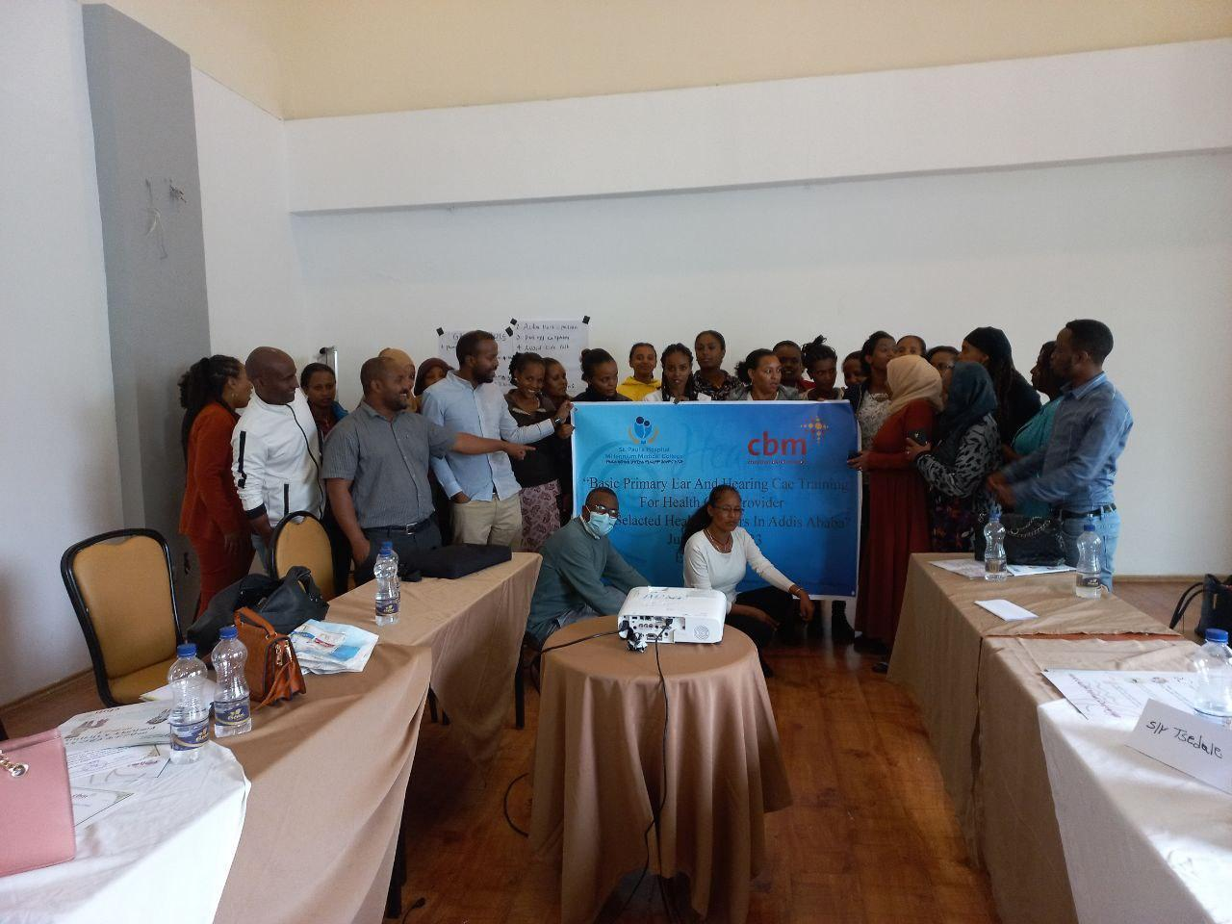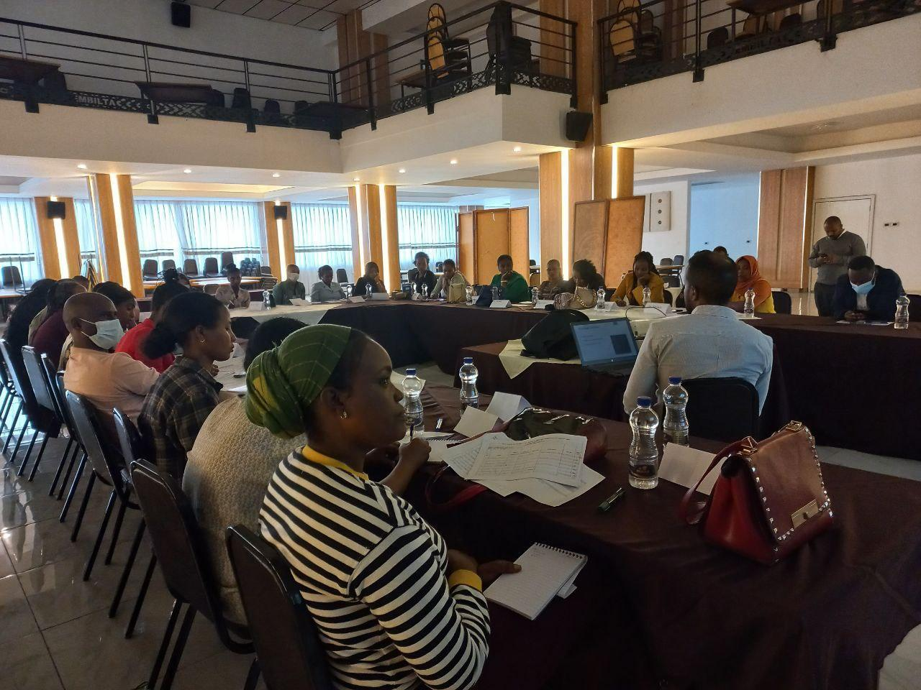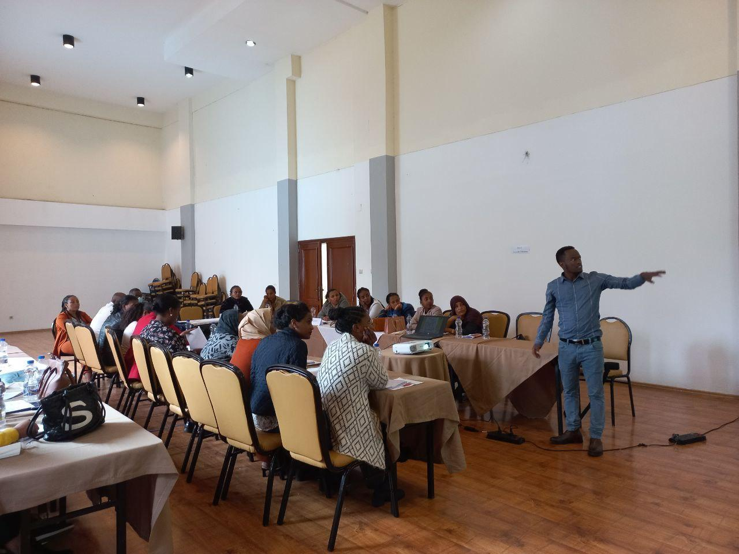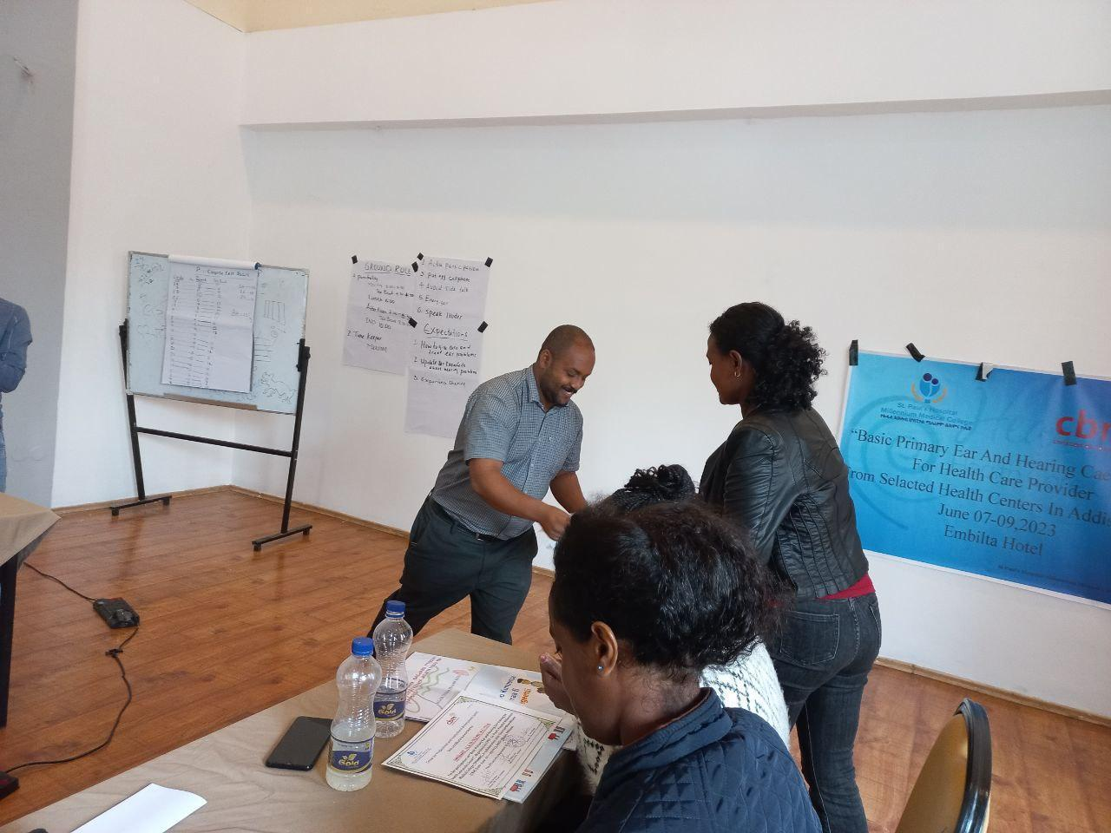

BPEHC training participants from selected Health Centers in Addis Ababa, Embilta Hotel.

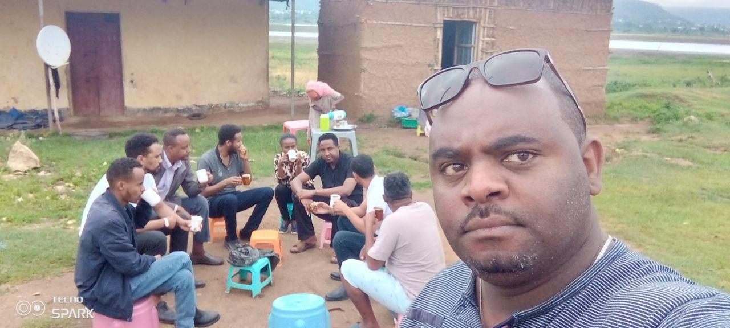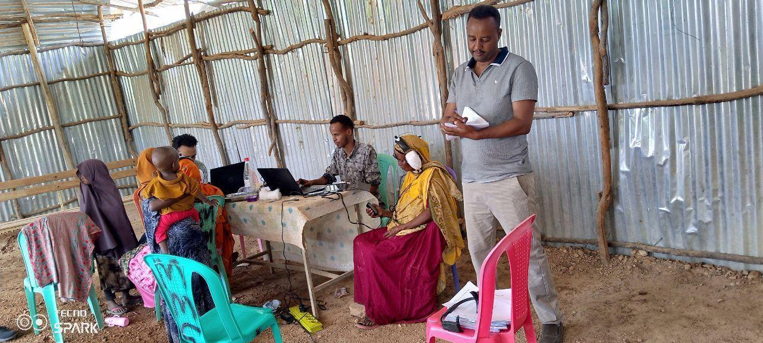

Survey team at Dengego- Diredawa Gode - Somale During Data collection

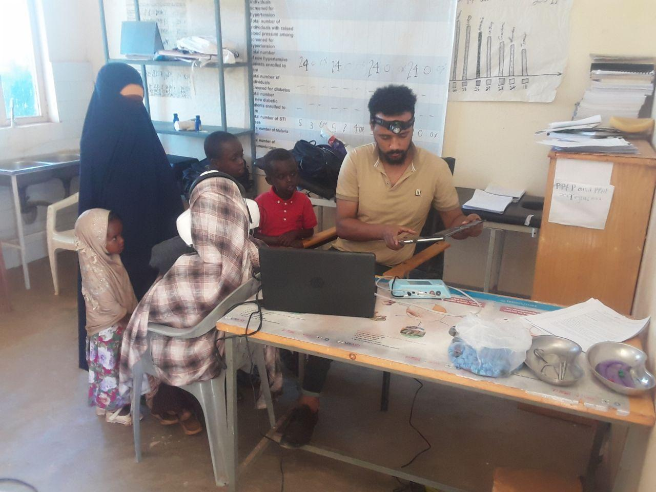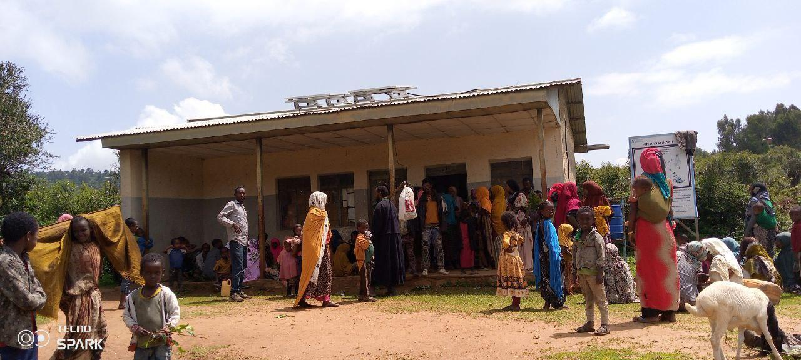

Obele- Degahbur-Somale Biftu Geda- East Hararge waiting area

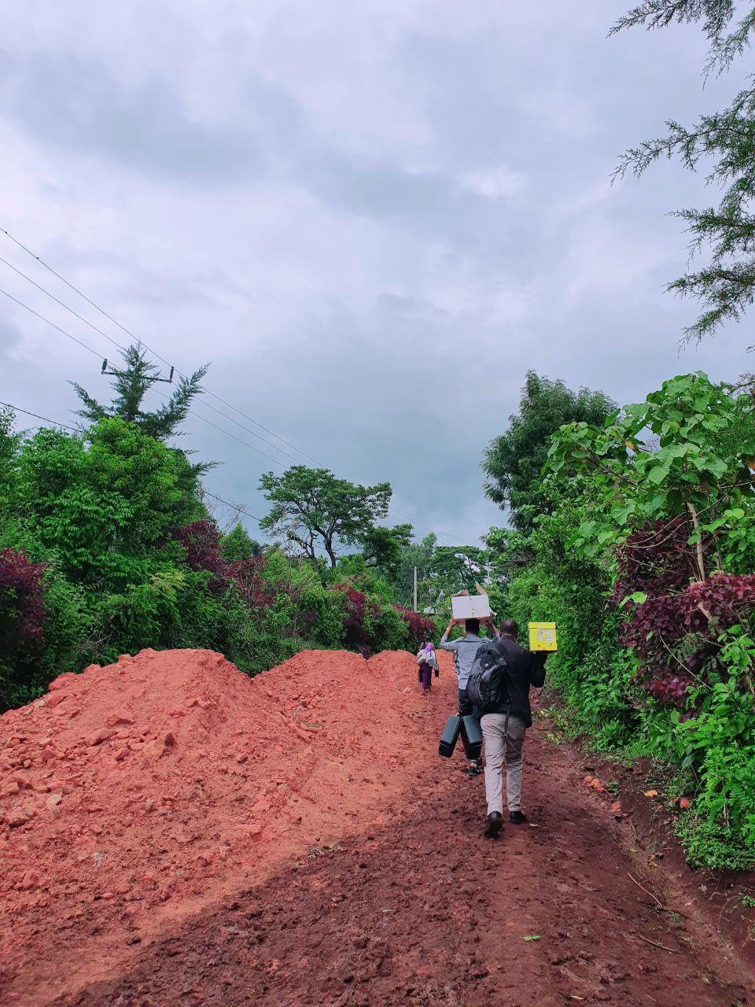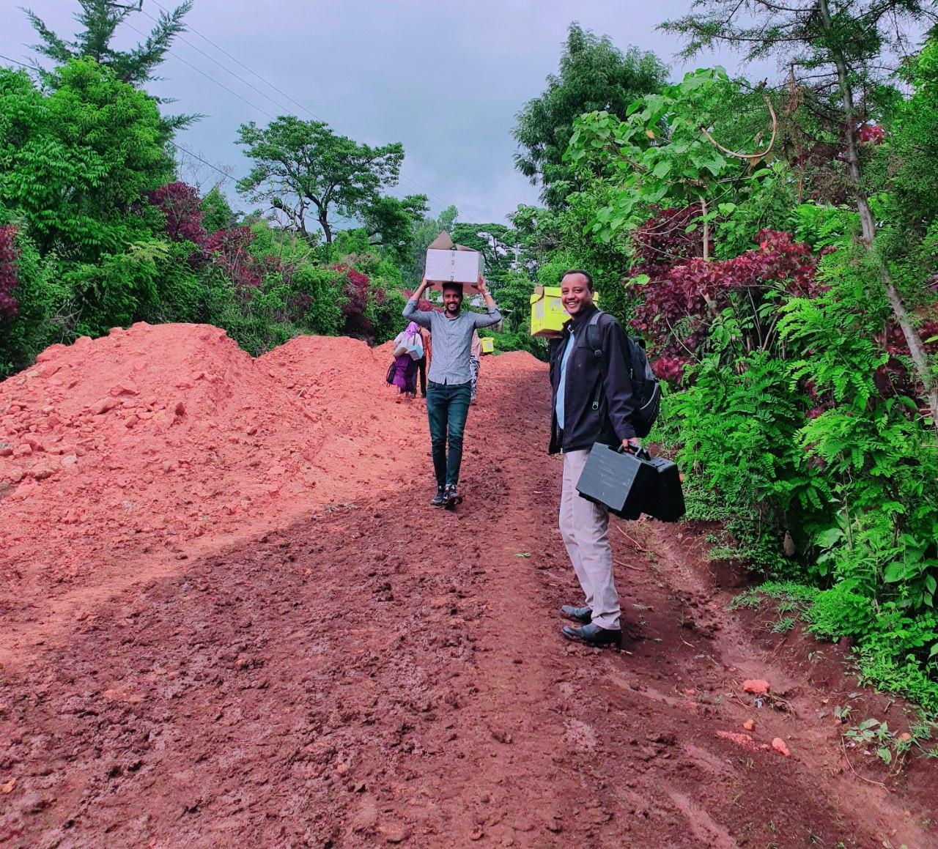

Survey team at Kersa - Jima zone

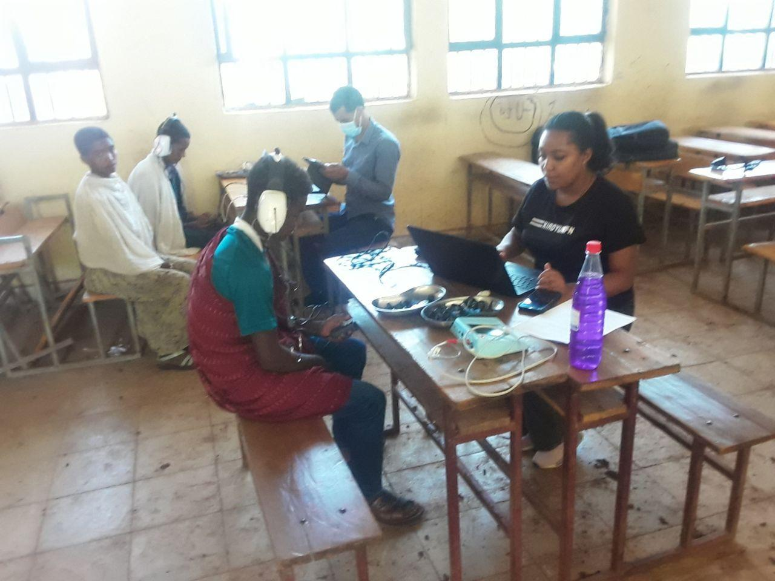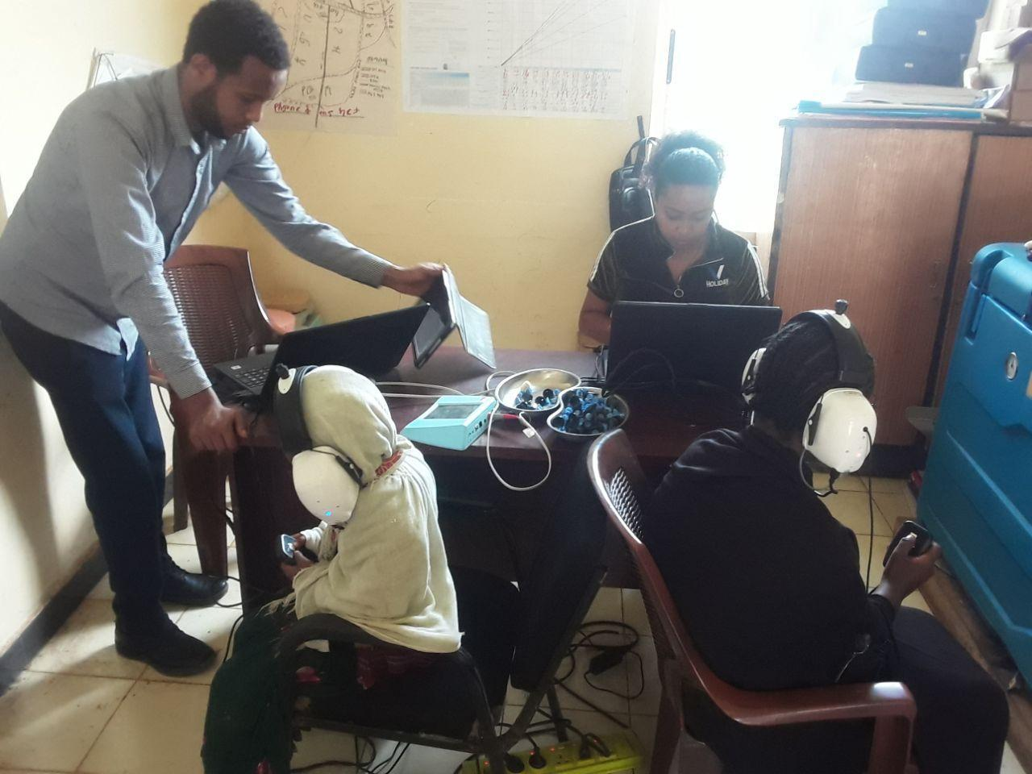

Mosobo-West Gojam Amber Zuria- East Gojam

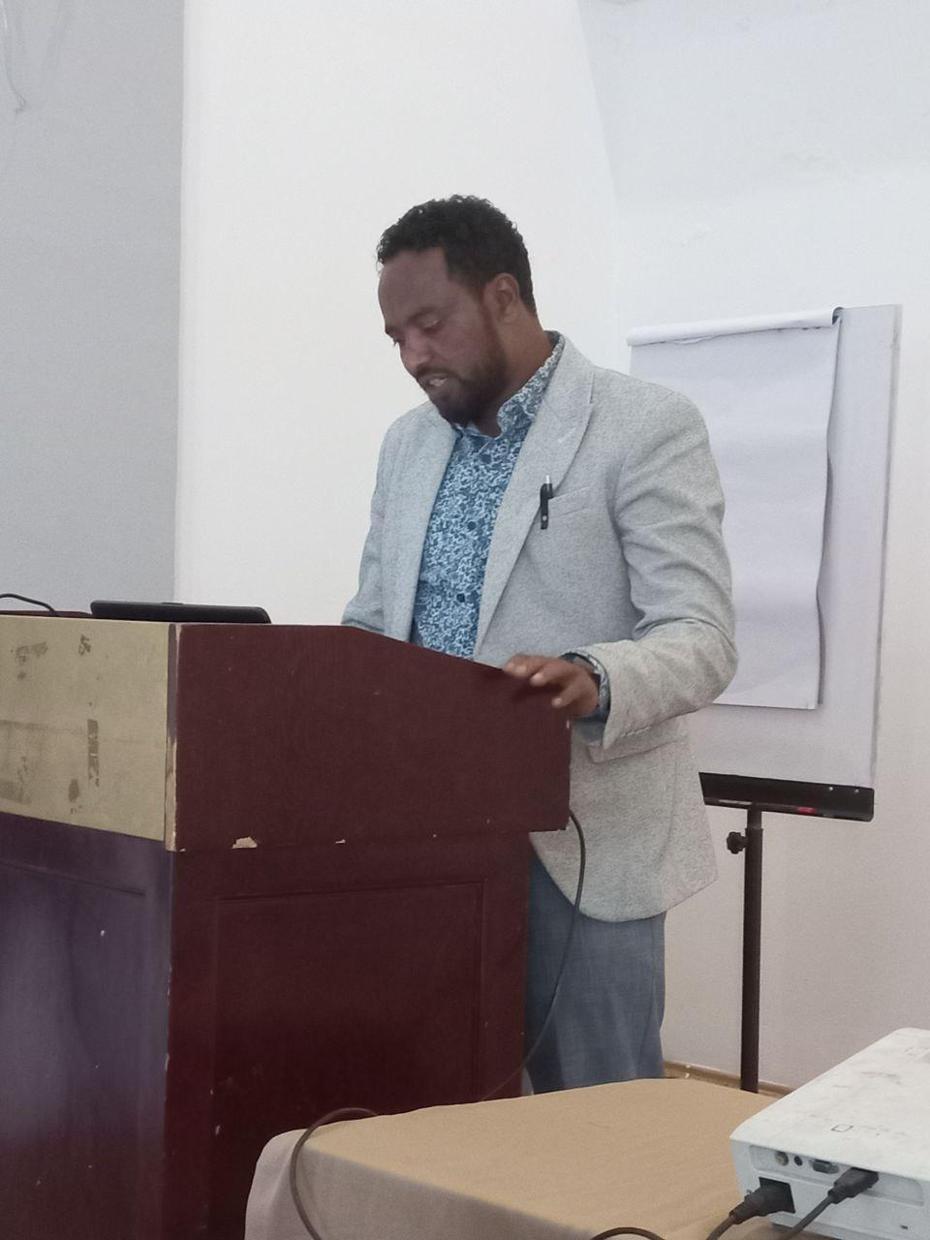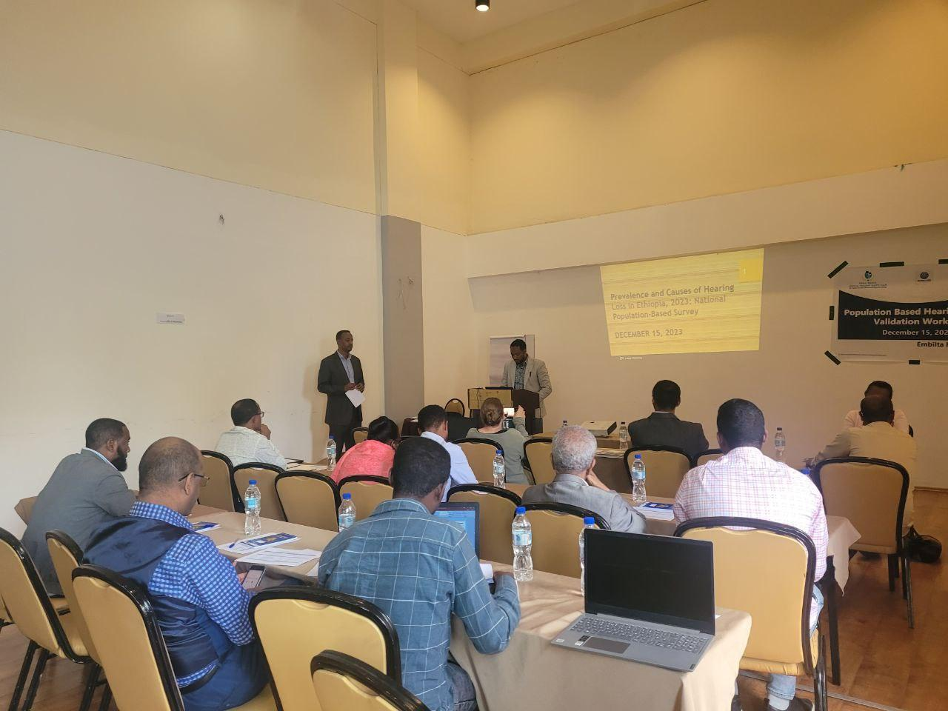

Opening remarks by MoH Official( Dr Elebabor Medical Service LEO) on Population Survey validation workshop.

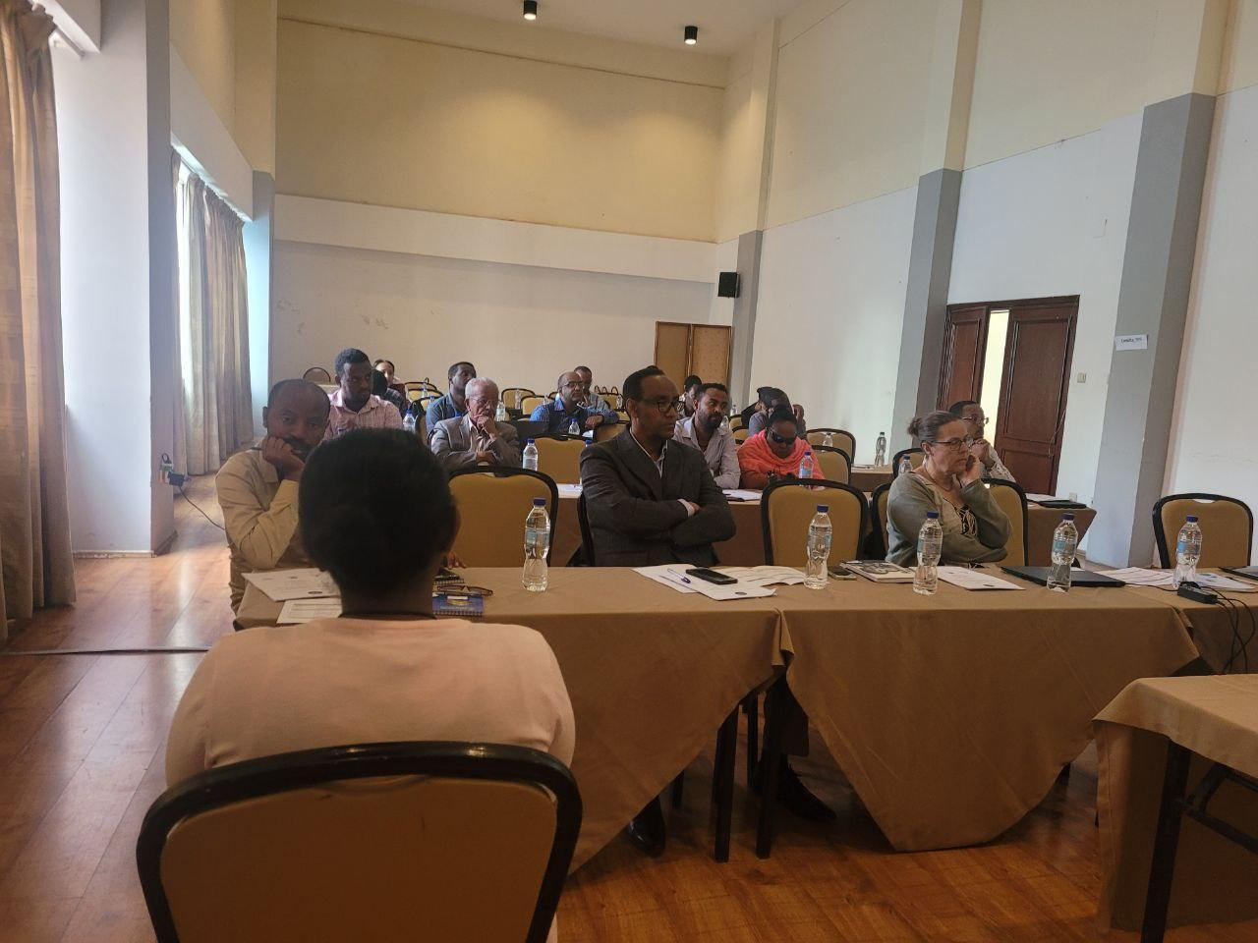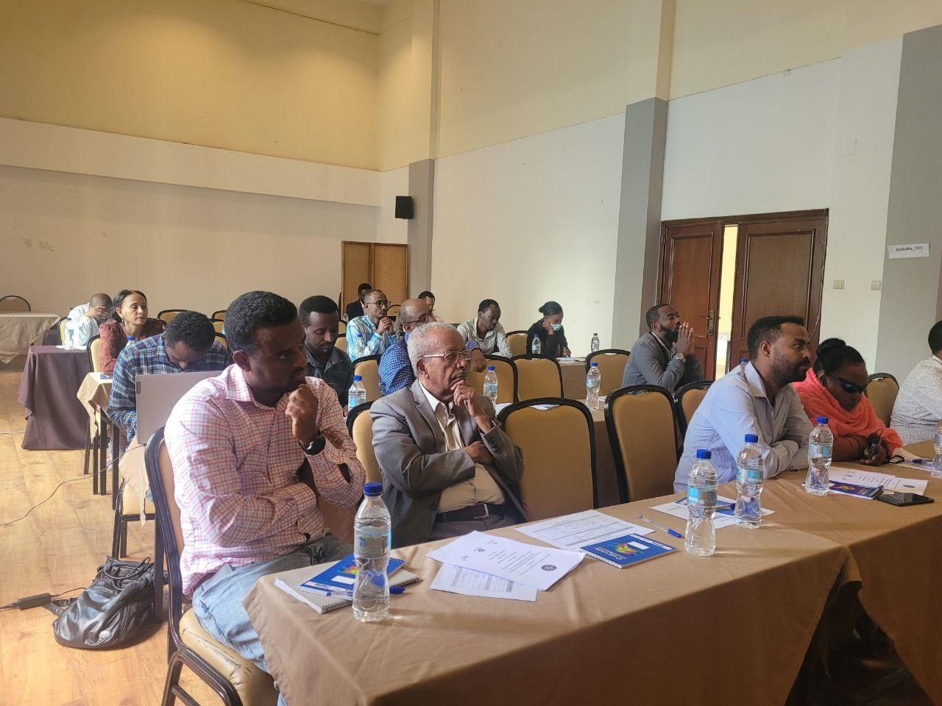

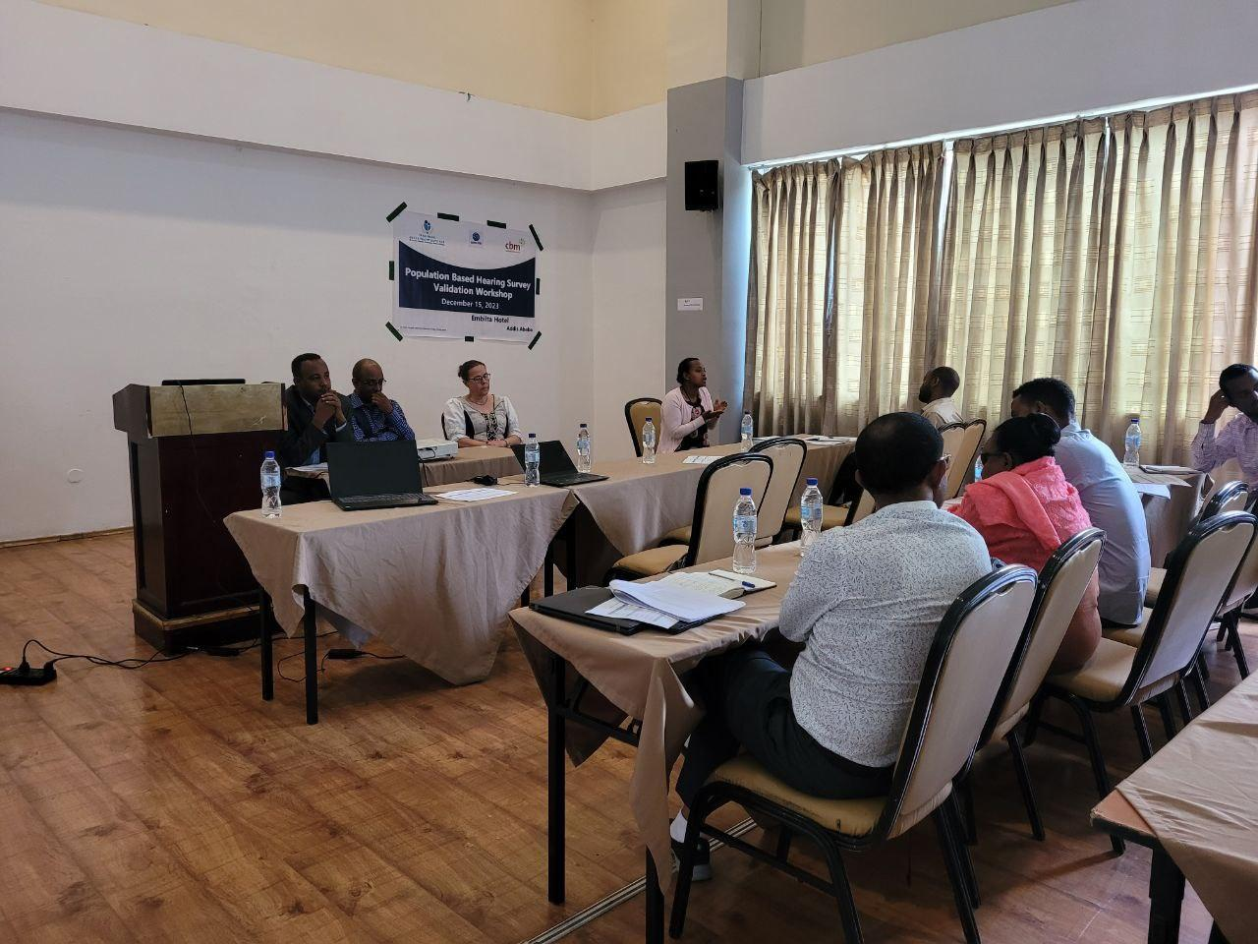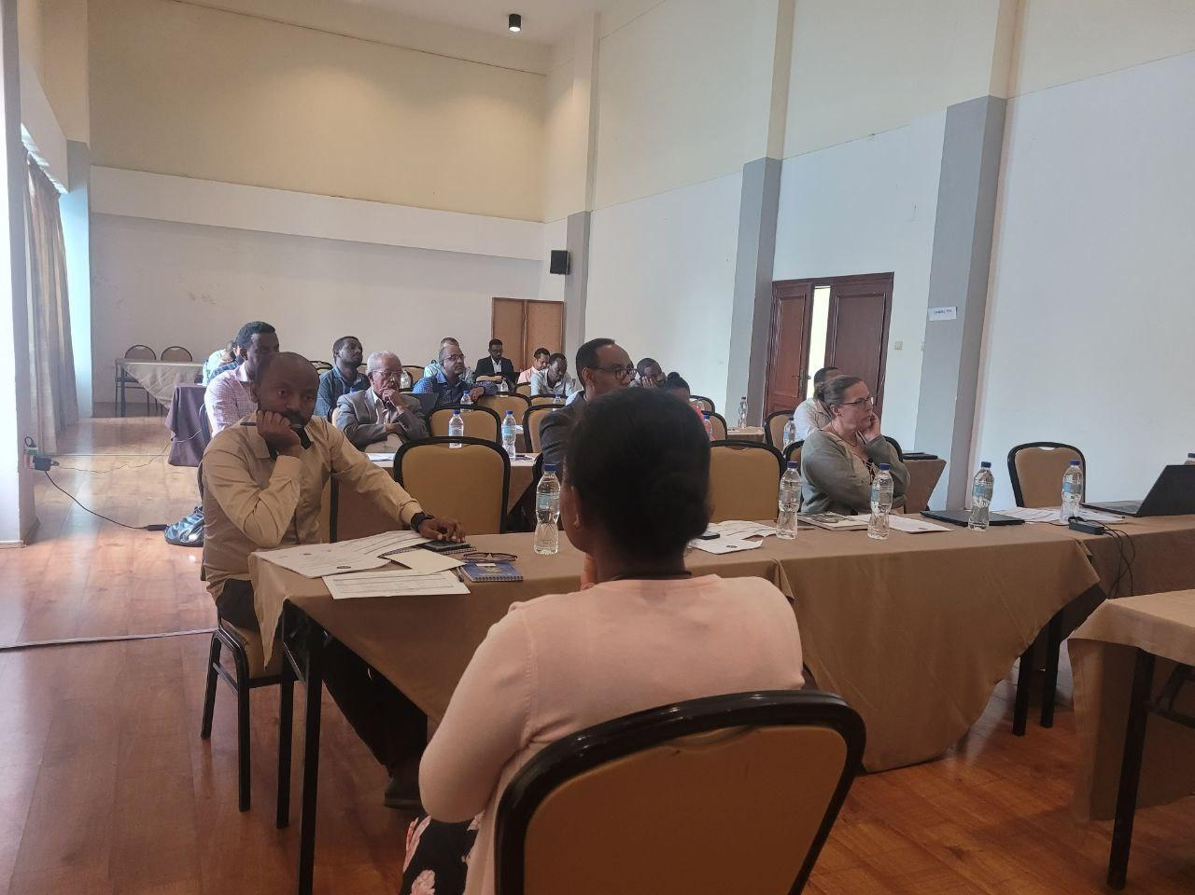

Presentation and discussions on the Population Survey Validation Workshop

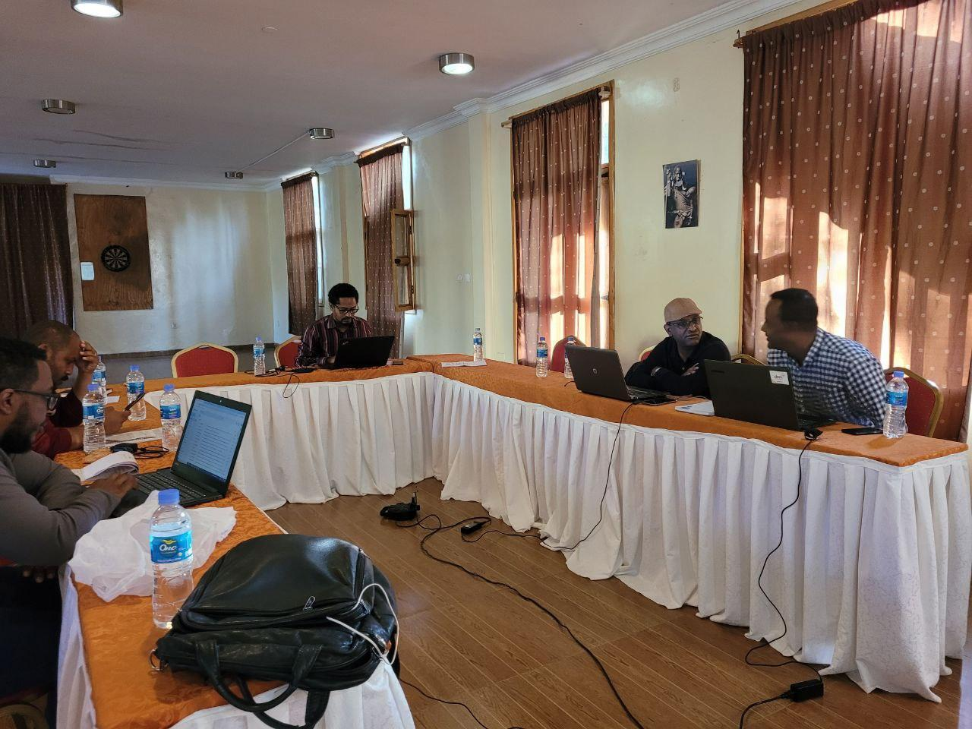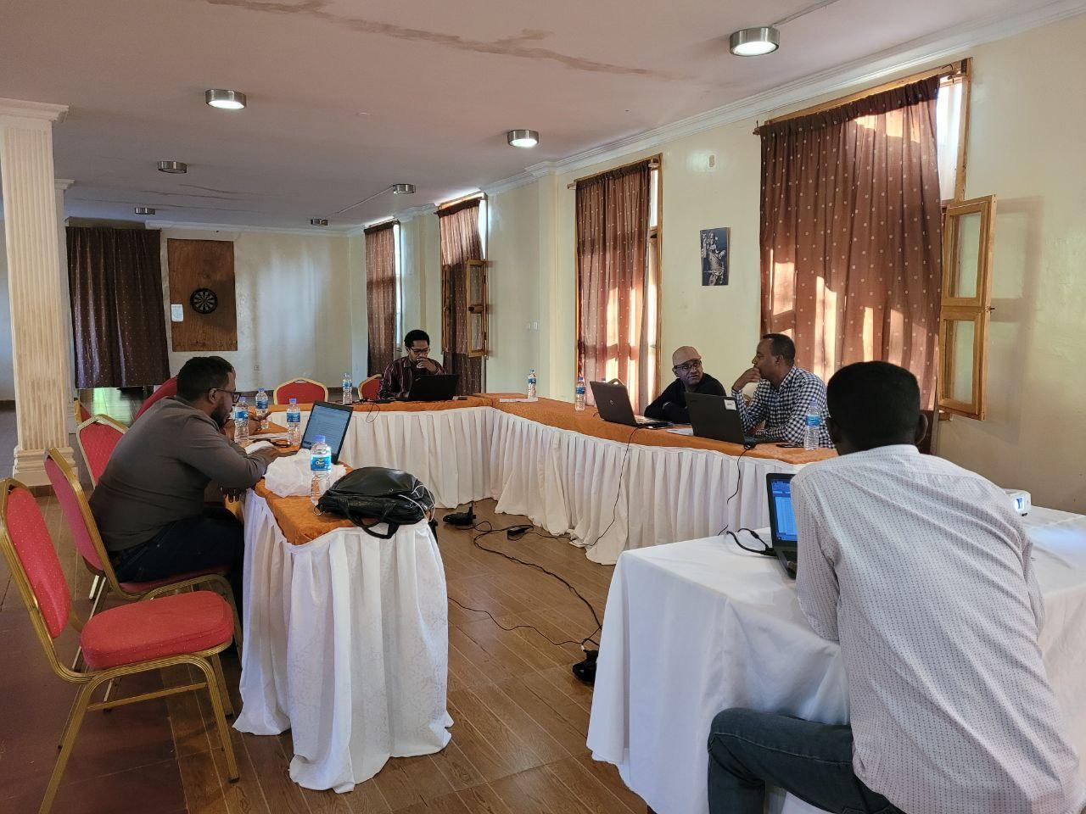

Manuscript write- up workshop in Arba Minch

* + 1. **Stories of Change**

No recorded history

* + 1. **Any other supporting documents as needed or agreed with CBM**

1. **COMMENTS FROM CBM**

It's noteworthy to know that St. Paul Hospital’s contribution is making a tangible impact on the lives of individuals in need. Providing access to essential ear and hearing care services not only improves health outcomes but also enhances overall quality of life. The credit goes to the dedicated team behind this initiative for turning CBM’s support into meaningful results.

During the reporting period, the project (P4257-MYP)/P10140 in implementation primarily focused on executing the national population-based survey, a key planned activity. This survey will successfully generate a milestone reference document for Ear and Hearing Care (EHC) services in the country, providing crucial prevalence data that was previously unavailable in Ethiopia. While the survey significantly contributed to reliable data for planning and decision-making, it also resulted in notable delays in project implementation, particularly in outreach services and other planned activities.

The travel-intensive nature of the survey, undertaken by the project coordinator and the survey team, led to delays in implementing various planned activities. Even so, the project experienced a significant burn rate than what was anticipated equivalent to 90.75%. Physical monitoring of the partner occurred twice, revealing findings and recommendations. The partner addressed some recommendations, such as rectifying the use of pre-financing without approval and adjusting budget allocation for administrative expenses without notifying CBM. However, certain action points remain unresolved, with the expectation that they will be addressed in the 2024 reporting period.

Despite these challenges, the partner demonstrated compliance with CBM's standards by delivering timely program and financial reports of acceptable quality. A personnel change occurred during this period, with the project coordinator resigning and being replaced by another ENT surgeon. Looking ahead to 2024, the partner needs to undertake re-planning for certain activities to enhance performance and contribute effectively to achieving the specific objectives of the multiyear project. Addressing the identified improvement areas will be crucial for the partner to make substantial progress and better contribute to meeting the project's specific objectives.

-End of document. Back to top-